Section 6:
Technical discussions on structure

6.1 Design earthquake loading and analysis of the CTV building

The analytical model developed by Mr David Harding for determining the seismic design action in the CTV building consisted of the south shear wall and the north wall complex linked by the floors. The columns and beams were excluded as their stiffness was small (relative to the walls) and they would have made only a minor contribution to the lateral strength and lateral stiffness of the building. That assumption was conservative and reasonable.

The north wall complex was much stiffer than the
south shear wall. Consequently there was a high degree of eccentricity of the centre of mass from the east- west centre of lateral stiffness in the building. In this situation NZS 4203:19841 recommended that the 3D spectral modal analysis method be used. This method is frequently referred to as the modal method or more specifically as the modal response spectrum method or the elastic response spectrum analysis (ERSA). However the Standard still permitted the equivalent static method to be used for this type of structure.

Mr Harding initially adopted the following assumptions:

• the building was intended for normal occupancy
and the associated risk factor was 1.0;

• ductile cantilever shear walls provided the lateral resistance and hence the structural type factor (S) was 1.0; and

• the material was reinforced concrete, which had a
material factor (M) of 0.8.

Analysis indicated that the fundamental period in both the east-west and north-south directions was equal to 1.06 seconds. This appears illogical when compared to Mr Harding’s calculated deflections in the east-west direction, which were less than half the deflections calculated in the north-south direction. However, it is not clear at what point on the structure the design drift locations applied.
NZS 4203:1984 placed limits on the numerical output obtained from a modal analysis. The base shear from a modal analysis was not permitted to be less than 90 per cent of that obtained from a corresponding equivalent static value. There was a second limit imposed: no storey shear above the base level was permitted to be lower than 80 per cent of the corresponding storey shear from the equivalent static analysis.

We have studied a copy of Mr Harding’s design calculations. As the computer input and output is not available there is some uncertainty about how some of the design values were obtained. Mr John Henry has also assessed the design calculations and we are in agreement with his assessment that:

1. Mr Harding found that the base shear from his modal analysis needed to be scaled up to 90 per cent of the equivalent static method.

2. Mr Harding then checked the 80 per cent minimum rule for the modal storey shear against the corresponding equivalent static values. For this exercise Mr Harding multiplied the equivalent static shears by 0.8. It appears that he adjusted the modal shear for the M factor by multiplying by 0.8. We think this was an error in that the S and M factors had already been incorporated in the modal analysis.

When the comparison was made it was found that the
80 per cent rule required the modal storey shears to be replaced by 80 per cent of the corresponding equivalent static values. In effect he appears to have designed the building for 80 per cent of the equivalent static lateral forces, which would be inappropriate. The Foreword to NZS 4203:1984 cautioned designers about the imprecision inherent in modal analysis. It stated that:

Designers should recognise that the precise properties of construction materials and of structural elements made from them are not clearly known. Furthermore, the interaction of these elements in a building frame under load is extremely uncertain, so that the total design technique is one of some degree of imprecision. In fact, the design results depend so much on the nature of the mathematical model of the building as envisaged by the designer that the use of more advanced techniques of earthquake analysis can easily lose validity.

Furthermore Mr Harding reduced the design loadings
for the south shear wall by a structural type factor, S, of 0.8. This increased the imbalance between the north wall complex and south shear wall because the reduction in load was applied to the latter wall only. The S factor, along with the material factor, M, reflects the available ductility in a system. The code commentary stated that a method of determining rational design actions for buildings having horizontal force-resisting systems in parallel, with differing S and M values in the direction being considered, is to assume that S and M are equal to 1.0 for all sub-assemblies and then design each using the load effect derived from this analysis and modified by multiplying it by the S and M values appropriate to the sub-assembly. It went on to state that as at 1984, this method has not been fully researched and therefore should be used with “prudence”, particularly for buildings over three storeys high. We see the code commentary as irrational as it required the south shear wall to work harder and dissipate more energy due to the high lateral strength of the north wall complex.

Mr Henry considered that the practical significance was that:

… this reduction of load leads to a corresponding reduction in the reinforcing requirements for the south coupled shear wall... This increased the imbalance in the building because the reduction in loads effectively only applied to the south coupled shear wall and not the much stiffer and stronger north core [complex].

Mr Henry thought the earthquake load on the whole building would have been largely governed by the yielding of the south shear wall. He said that once it yielded the system would essentially be limited to the load at which yielding occurred and the building would rotate about the north wall complex with any
application of a higher load level. However the non- linear time history analysis (NLTHA)2 results show that this rotation about the north wall complex was partially reduced by the torsional mass inertia of the floors.

The building deflections are set out on pages S15 and
S16 of Mr Harding’s original calculations. It is unclear if the inter-storey deflections are from the modal or equivalent static analysis. Mr Harding said in evidence they appear to be for the equivalent static method. Accordingly K was equal to 2.0 as set out in Clause 3.8.1.1 of NZS 4203:1984. He said the wall shear for a dynamic analysis is typically lower than for the equivalent static analysis so it was assumed at this time that these deflections were also lower and therefore not recorded in the calculations.

Mr Henry did not see calculations that showed that the rotation of the building had been taken into account to determine the maximum deflections at the south corners. He said it is likely that the calculated deflections were for the centre of mass and a separate calculation was needed to determine the deflections at the corners. Mr Harding accepted that he did not check corner deflections in the calculations. This meant the deflections were likely to have been underestimated.

The calculations show the elastic inter-storey deflections were multiplied by a K/SM factor to give the maximum inter-storey deflection, with structural
type and material factors both equal to 1.0. Mr Harding did not adjust his deflections when he changed the structural type factor for the south shear wall. An S factor of 0.8 would give greater inter-storey deflections when using the K/SM factor.

There were also issues with the approach to the calculation of deflections in NZS 4203:1984. These are discussed in Volume 2, Recommendation 60 and in section 6.2.5.3 of Volume 4 of our Report. When a plastic hinge is formed at the base of the wall, it will rotate about the plastic hinge. This will result in greater inter-storey deflections for the lower levels than the scaled elastic deflections.

In summary, the critical inter-storey deflections that were imposed on the columns were not calculated in the more critical corner locations and did not appear to account for a revised structural type factor. We conclude that the deflections considered in Mr Harding’s design were not consistent with the design requirements in NZS 4203:1984.

6.2 Landsborough House

6.2.1 Introduction

The structural calculations of Landsborough House were essentially used as a guide by Mr Harding when designing the CTV building. Both the CTV building and Landsborough House (see Figure 71) were similar multi-storey shear wall buildings, but there were some significantly different structural characteristics that led to their differing performance during the February earthquake. Some of these major differences are discussed below.

Figure 71: Landsborough House

As discussed in section 2.1.2.2.3, Landsborough House was designed by Mr Henry when he worked at Alan M Reay Consulting Engineer (ARCE) between 1984 and 1985. A building permit was issued on 9 August 1985. It has north-south frames that were designed to support the majority of the vertical loads. Landsborough House has eight floor levels and a floor plate measuring 24.4 by 23 metres (see Figure 73). In comparison, the CTV building had six floor levels, and a larger floor plate, measuring 30.25 by 22.5 metres. The structural characteristics were similar, in that both buildings were:

• described as shear wall protected gravity frame
systems;

• torsionally sensitive as the centre of lateral load resistance was eccentric from the centre of mass; and

• lacking full ductile detailing (to the code seismic
provisions) in the columns and beam-column joints.
The Landsborough House building survived the February earthquake but was added to the Canterbury Earthquake Recovery Authority’s demolition list in January 2012.

6.2.2 Shear wall core and floor connection

Landsborough House had a closed shear core, which was located within the building’s floor plate. A closed shear core is more efficient at resisting torsional and flexural actions compared to an open wall configuration. All four shear walls were connected at the corners to provide a stiff system compared to the open and consequently more flexible wall configuration used in the CTV building. Since a closed shear core is stiff it results in smaller inter-storey drifts than an open wall system, if all other structural details are identical. If the walls crack in shear and/or torsion there is a degradation in stiffness. This problem was reduced in Landsborough House by incorporating diagonally reinforced coupling beams in the south wall of the shear core. When the building was subjected to east- west seismic actions it would have induced a direct and torsional shear demand on the four shear walls, as illustrated in Figure 72. The direct and torsional shear demands acted in opposite directions on the north shear wall whereas they acted together on the south shear wall. The result is that the south shear wall sustained higher shear forces than the other walls. The southern wall had diagonally reinforced coupling beams at both its east and west ends. The concept of a coupled shear wall is that the inelastic action takes place by yielding in tension and compression of the diagonal reinforcement, which gives a shear deformation mode. A diagonally reinforced coupling beam does not degrade in stiffness to the same extent as a normally reinforced beam undergoing inelastic cycles. Therefore the core wall system maintains its stiffness during inelastic cyclic behaviour during an earthquake. This is important in limiting the inter-storey displacements.

N

Key
= Torsional shear flow
= Direct shear force

Figure 72: Seismic actions on Landsborough House due to an east-west earthquake

In Landsborough House the beams spanned in the north-south direction and were connected directly into the end of the walls, (see Figure 72). Under north-south seismic actions the inertial forces could be transferred directly into the walls. There was also continuous reinforcement from the floor going into the walls. Since the wall core was inside the building floor plate there was shear transfer capability between the slabs and the walls. Mr Henry described the floor connection to the shear wall core as a “spanner effect” with the floors encompassing the shear core on three sides. The floor reinforcing could act in tension to clamp the floor to the wall sides.

Figure 73 shows the locations of the shear walls and beams in the Landsborough House and CTV buildings. In Landsborough House the centre of mass was highly eccentric to the centre of lateral stiffness. With this arrangement the greatest inter-storey drifts occurred in the east-west direction due to the torsional response of the building. In this structure the beams spanned in the north-south direction and the rotation of the columns (due to drift in the east-west direction) was only restricted by the floor slab at each floor level. As the floor was flexible compared to the columns there was little rotational restraint provided and this reduced the structural actions induced in the columns due to inter-storey drift.
The design of the CTV building can be distinguished from Landsborough House. In the case of the CTV building, the beams spanned in the east-west direction. Modal response spectrum analysis of the CTV building shows that, like Landsborough House, significant inter- storey drifts occurred in the east-west direction due to the torsional resistance of the building. However, in this case the orientation of the beams was such that they restrained the rotation of the columns at each floor, which increased the structural actions in the columns associated with inter-storey drift.

In the CTV building the only area where inertial force from the floors could be transferred to the north wall complex was through the drag bars (installed in 1991) and by flexure, shear and direct tension in the region between the walls on lines C and C–D. The tie force was dependent on the strength of this limited area (shown in Figure 73), which was reinforced with mesh, additional 12mm diameter bars and some embedded beams bars. The arrangement used in Landsborough House was more direct and robust.

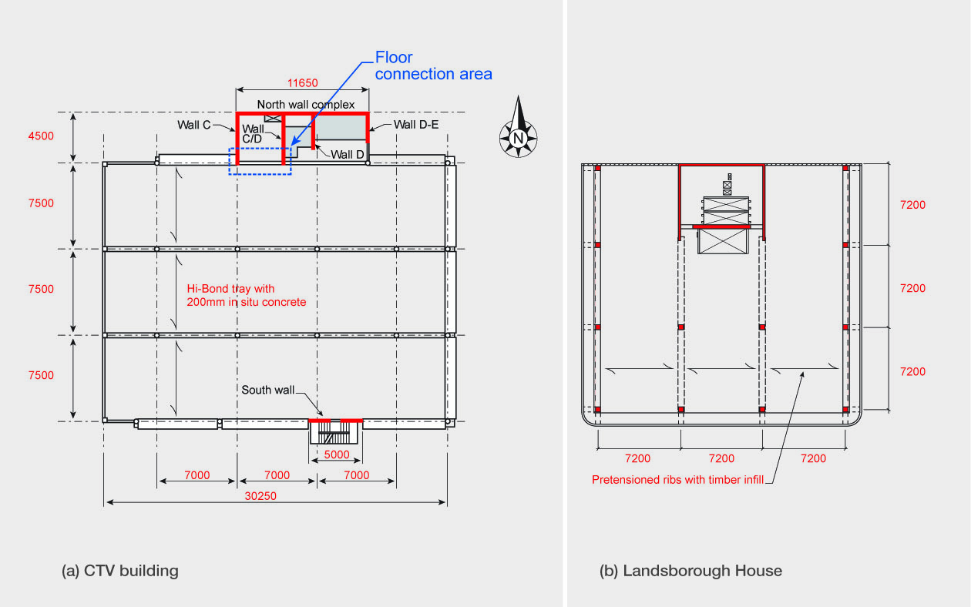

Figure 73: Comparison of shear wall layout and floor connection

6.2.3 Comparison of Landsborough House and
CTV building

A summary technical comparison of the two buildings is given in Table 1.

Table 1: Comparison of Landsborough House and CTV buildings

Item Landsborough CTV
No. of levels | 8 | 6
Central column dimensions | 400mm square | 400mm diameter
Confinement | 10mm stps. @150c/c | 6mm spiral @250 pitch
Column longitudinal reinforcement | 4-H28+4-H24 base p = 2.67%  1  4-H24 top p = 1.1%  1 | 6-H20  p = 1.5%
Confinement proportion to gross area | 0.43% | 0.089%
Confined concrete divided by gross area | 0.68 | 0.585
Cover to longitudinal bars | 40mm | 50mm
Max. axial load ratio (approx.) | 0.3 | 0.4
Slab | Pretensioned ribs and timber infill,  75 in situ concrete | Hi-Bond with 200mm in situ concrete
Reinforcement | 665 mesh and H10 @300c/c over beams | 664 mesh and H12 @120c/c over beams

6.2.4 Beam-column joints

The typical beam-column joint in Landsborough House was reinforced with four 10mm diameter square ties as shown in Figure 74(a) and (b). The bars protruding out from the bottom of the precast concrete shell beams were lapped side by side in the beam-column joints with two additional 20mm bars laid in the trough of the shell beam to give reinforcement continuity right through the bottom of the joint.

The columns for the CTV building were reinforced with
a 6mm diameter spiral at a 250mm pitch. The structural drawings show this spiral going through the beam- column joints. However evidence given at the hearing by Mr Graham Frost and Dr Robert Heywood suggests that no spiral reinforcement was installed in the joint zones. The CTV building typically had two 28mm bottom bars bent up and anchored in the middle of the connection zone with effectively no beam-column joint zone shear reinforcement. In comparison, the Landsborough House joint detailing would give better performance in an earthquake. The CTV joints would quickly degrade in strength with the hooked bottom bars vulnerable to pull out as described in section 6.3. The basic mechanism of shear transfer in the Landsborough House beam-column joints is shown in Figure 74(c). The shear forces lead to diagonal compression and tension stresses in the joint core, with the latter giving diagonal cracking. To prevent shear failure by diagonal tension under cyclic loading, usually along a potential corner-to-corner failure plane, both horizontal and vertical shear reinforcement is required. In Landsborough House the continuous beam bars allowed a diagonal compression strut to be mobilised across the full width of the joints. The progressive cracking along with some slip of the beam bars would have led to a loss in joint strength if there was significant cyclic inelastic demand placed on the beam or column reinforcement. However, the high stiffness of the shear core in Landsborough House protected the beam-column joints from this inelastic deformation. In contrast to this, the CTV joint zones were sensitive to strength degradation in situations where the bottom bars were subjected to tension. In this situation, due to the lack of continuous reinforcement through the joint zone, its performance was dependent on the tensile strength of the concrete, which was unreliable and, once it cracked in tension, strength degradation would occur rapidly under cyclic loading conditions.

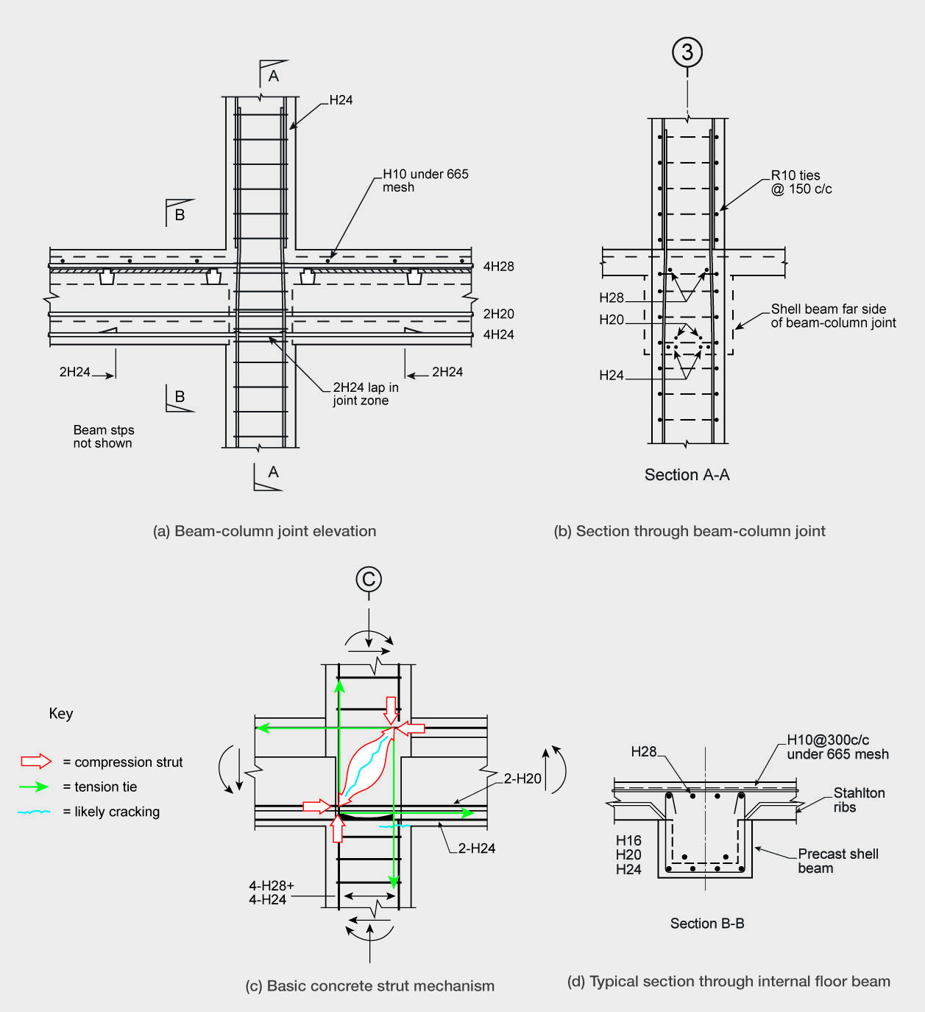

Figure 74: Beam-column joint detailing

6.2.5 Columns

One criterion for the performance of columns is the
ratio of the area of confined concrete against the area of unconfined concrete. The bigger the area of unconfined concrete the greater the drop in load capacity when spalling occurs. The ratio of confined concrete to gross area of the column was 0.68 in Landsborough House and 0.585 in the CTV building. Landsborough House had a larger ratio of confined concrete, which would give a superior performance after spalling occurred.
The Landsborough House columns were confined with 10mm ties at 150mm spacing at the top and bottom of the column height, with 250mm spacing in the central region. This would not have been consistent with full ductile seismic requirements of
the code (had they applied). However the detailing of
the columns does show an increased reinforcement content in the potential plastic hinge regions. The confinement reinforcement in the potential plastic hinge zones increases column ductility and this
enables it to sustain increased inter-storey drifts before failure. The proportion of confinement reinforcement

to the gross concrete volume in the potential plastic regions was 0.43 per cent in Landsborough House. The corresponding proportion in the CTV columns was 0.089 per cent, which is one fifth of that in the Landsborough House columns. Dr Reay agreed that this made the Landsborough House columns more robust.

6.2.6 Concrete floor

In Landsborough House, precast shell beams supported the precast prestressed Stahlton ribs with timber infills and a cast in situ concrete slab on top. The CTV building had a steel Hi-Bond floor system with total depth of 200mm in situ concrete. Once the concrete hardened the floor became a composite concrete-steel member. In this type of floor, creep and shrinkage of the concrete over time results in stress redistribution and sagging of the floor between the supporting beams. In Landsborough House the creep of the prestressed beams may have had a tendency to lift the floor, although Dr Reay disagreed with that based on his practical experience.

The proportion of slab reinforcement in Landsborough House was also higher since it had a thinner concrete slab than in the CTV building. The lower proportion of reinforcement could have had adverse effects in terms of controlling floor slab cracking in the CTV building.

6.3 The structural system of the
CTV building

6.3.1 General description of building

We gave a general description of the CTV building in section 1. As we noted there, the building had six main floors. There was a service floor at level 7 for the lift and other services. There was a lightweight roof at that level.

A B C D E F

4750
7000 7000
7000
4500

11650

North wall complex
5
Landing N
Wall C
Wall D-E

Toilets
4500

Stair
Lifts

Wall C-D Wall D
4
Precast beams

Rectangular columns to west wall (typical)
7500
West block wall up to level 3

Precast beams
3

400mm O
columns (typical)
7500

Spandrel
22500
(typical)

Precast beams
Hi-Bond floor slab
2

Precast beams
7500
1
South shear wall
Precast beams

30250
5000

Figure 75: Floor plan for levels 3–6

Figure 75 shows a typical floor plan of the building for levels 3, 4, 5 and 6. Level 2 was similar except for a stairwell opening in the floor slab on the south side of the building. Level 1, at ground level, was a concrete floor cast on grade. The structural wall complex on the north side of the building provided the principal lateral- force-resisting elements for the forces in the north- south direction and approximately half the forces in the east-west direction. It consisted of a wall on line 5, which had a length of 11.65m, and four finger walls at right angles to the main wall that spanned between lines 5 and 4 in the case of the walls on line C and C-D,
and part way to line 4 in the case of the walls on lines D and D-E. A coupled shear wall on the south side of the building in line 1 contributed to the lateral force resistance in the east-west direction

There was a block wall on the west side (line A) of the building between levels 1 and 4, which was supported on the ground floor at level 1 and by precast beams at levels 2 and 3. Above this level there were no beams on line A. The lack of damage to this wall prior to the February earthquake indicates that it was either

effectively separated from the structure for the September and Boxing Day earthquakes or that it restrained the north-south inter-storey drifts sufficiently to prevent it being damaged to a noticeable extent. However, in the February earthquake it is likely that there was contact between the wall and the surrounding concrete frame.

Precast beams on lines 2 and 3 were supported
by columns, and for the beams on lines 1 and 4 by columns and the structural walls. The floors were metal tray, Dimond Hi-Bond, with in situ concrete to give a total depth of 200mm. The clear span between the precast beams that supported the floors was 7.1m, which was close to 500mm in excess of the span recommended by the manufacturer. The in situ concrete was reinforced with 664 mesh. To compensate for the fact that the span length was greater than the recommended value, high strength 12mm saddle bars (380MPa) were added at 120mm centres over the beams. It is understood, though it is not shown on the drawings, that there may have been a second layer of mesh in the concrete, which was draped from above the beams to the middle span of the slab. This was to provide tensile membrane action to support the floor in the event of a fire and loss of integrity of the Hi-Bond tray.

All the columns, except those on line A and a single square 400mm column on level 1 (on grid line 4 between grid lines D and E), were circular and had a diameter of 400mm. The columns on line A were rectangular in section measuring 400mm parallel to line A and 300mm at right angles. All the columns were cast in situ.

All the columns were designed for gravity loading as it was assumed that the shear walls would limit the inter-storey drifts and prevent significant seismic actions being induced in the columns. Confinement reinforcement was kept to a minimum. For the circular columns the confinement reinforcement consisted of 6mm bar spirals at a pitch of 250mm. For the rectangular columns R10 ties were placed at 250mm centre to centre. Due to the low level of confinement reinforcement and the relatively high axial loads the columns would have had limited ductility.

6.3.2 Requested information

The Royal Commission studied a number of reports on the CTV building’s structural performance during the earthquakes. During our investigation information was sought on a number of aspects that we considered had not received adequate consideration. A minute was issued dated 27 June 2012 requesting that interested parties respond to a number of questions.
The response to the minute was limited, but what was received is discussed in the sections below. Where we judged the response to be inadequate we have given the conclusions of our own analyses.

The minute from the Royal Commission asked the following questions:

South wall (line 1)

This wall appears to have been designed as a coupled shear wall.

(a) Would this wall have behaved as a coupled shear wall in the Canterbury earthquakes? In particular would the coupling beams have yielded with plastic hinges forming in each of the walls?
(b) What influence would the floors in the building have had on the behaviour of the south wall?
(c) Was there an adequate load path to transmit the inertial forces from the floors into the south wall?
(d) How do the design inertial forces between the wall and the floors compare with the corresponding design actions calculated from NZS 4203:1984 and NZS 1170.5?
North wall complex (between lines 4 and 5)

In this wall complex there are four walls which could provide lateral force resistance in the north-south direction and one wall on line 5 to provide lateral force resistance in the east-west direction.

(a) Given the lateral force resistance in the east- west direction what level of ductility would be appropriate in designing the wall and the inertial forces generated between the wall and the floors?
(b) What was the load path for the shear transfer between the floors and the wall complex?
(c) Would the wall complex warp under the action of this shear transfer? Can you account for the observed vertical cracking in the wall complex?
(d) What other structural actions are associated with shear transfer from floor into the structural wall complex?
(e) Is the detailing of the junction between the floors and the wall complex adequate to resist the shear force and associated actions?
(f) How do the predicted magnitudes of shear force transfer between the floors and the wall complex correspond to the design values found from NZS 4203:1984 and NZS 1170.5:2004?

There was one written response that dealt with design type actions for the south shear wall. Otherwise, the response to the minute was limited in extent, although some comments were made by those giving expert evidence during the hearing.

6.3.3 North wall complex

The north wall complex is shown in Figure 76. The channel-shaped form of the wall complex results in it having a flexural centre (sometimes known as the shear centre) located approximately 0.7m to the north of line 5. However this assumes that the section is fully restrained against warping, which is not the case due to the openings in the floors for the stairs and lift shaft, which are located alongside the wall. To make an allowance for this partial restraint against warping we have assumed that the effective shear centre was 0.5m north of line 5.

6.3.3.1 Assessment of north-south design actions

Some approximate calculations have been made by the Royal Commission to assess the capacity of the connections between the north wall complex and the floors. The seismic weight of each elevated floor (levels 2, 3, 4, 5 and 6) between lines 1 and 4 was assessed as 4900kN (we note this is an approximate value only). For level 6 the parts and portions lateral force coefficient from NZS 4203:1984 is close to 0.25. Under the 1984 Loading Standard (NZS 4203:1984) this coefficient could be used to calculate the design force between the floors and the lateral-force-resisting elements. Use of this value gives a total lateral design force of 1225kN for the north-south direction at line 4. The total north-south design force acting on the north wall complex consists of the 1225kN plus the additional seismic lateral force due to the seismic weight between lines 4 and 5.

Figure 76 shows the north wall complex with voids for the lift shaft and the stairs preventing effective lateral force transfer to the finger walls D and D-E. This was the situation identified by Mr John Hare of Holmes Consulting Group (HCG) in 1990, which led them to inform their client and Alan Reay Consultants Limited (ARCL) of the lack of connection for seismic forces between the floors and the north wall complex. As recounted in section 2.4, ARCL designed drag bars to enable lateral forces to be transferred to the walls D and D-E. A critical section for transfer of this lateral force is just to the south of the beam on line 4. At
this location there are 19 high-strength 12mm bars
(fy 380MPa) located in the gap of 3.55m between walls
C and C-D. In addition to the reinforcing bars there
is 664 mesh in the floor. Allowing for a 45° dispersion of tension force through the beam on line 4, which is connected to the walls C and C-D, gives an effective width of mesh of 5.5m at the south face of the beam
on line 4, (see Figure 76(a)). Using a strength reduction
factor of 0.9 and basing the tensile strength on the minimum specified yield strength for the bars and the stress at the 0.2 per cent proof strain for the mesh (485MPa) gives a tensile capacity of close to 95 per cent of the design action (1225kN). A further critical section is at the location where the 12mm bars are terminated, which is close to 1.75m from the face of the beam on line 4. Allowing for further 45° dispersion of this force to this section gives an effective width of 9m, which contains 664 mesh (see Figure 76(a)). The tension capacity at this section is 723kN, which is close to 60 per cent of the design action. Due to the limited out-of-plane strength and flexibility of the wall on line 5, without the addition of the drag bars, virtually all tie force in the north-south direction would have been resisted by the walls C and C-D. Each drag bar at level 6 had a design capacity of 300kN, which gave a total capacity approximately equal to the design lateral force at this level.

Similar, though more detailed, calculations were carried out by HCG in their assessment in 1990, and separately by Mr Geoffrey Banks at ARCL in designing the retrofit drag bars. Due to the limited out-of-plane strength and flexibility of the wall on line 5, without the addition of the drag bars, virtually all tie force in the north-south direction would have been resisted by the walls C and C-D. The lateral force coefficients from the parts and portions criteria in NZS 4203:1984 reduced for the lower floor levels in the building. On this basis Mr Banks found that drag bars were not required for levels 2 and 3. For these levels it was deduced that the design forces nominally resisted by these walls could be redistributed to the walls C and C-D with the torsional component resisted by the walls on lines 1 and 5.

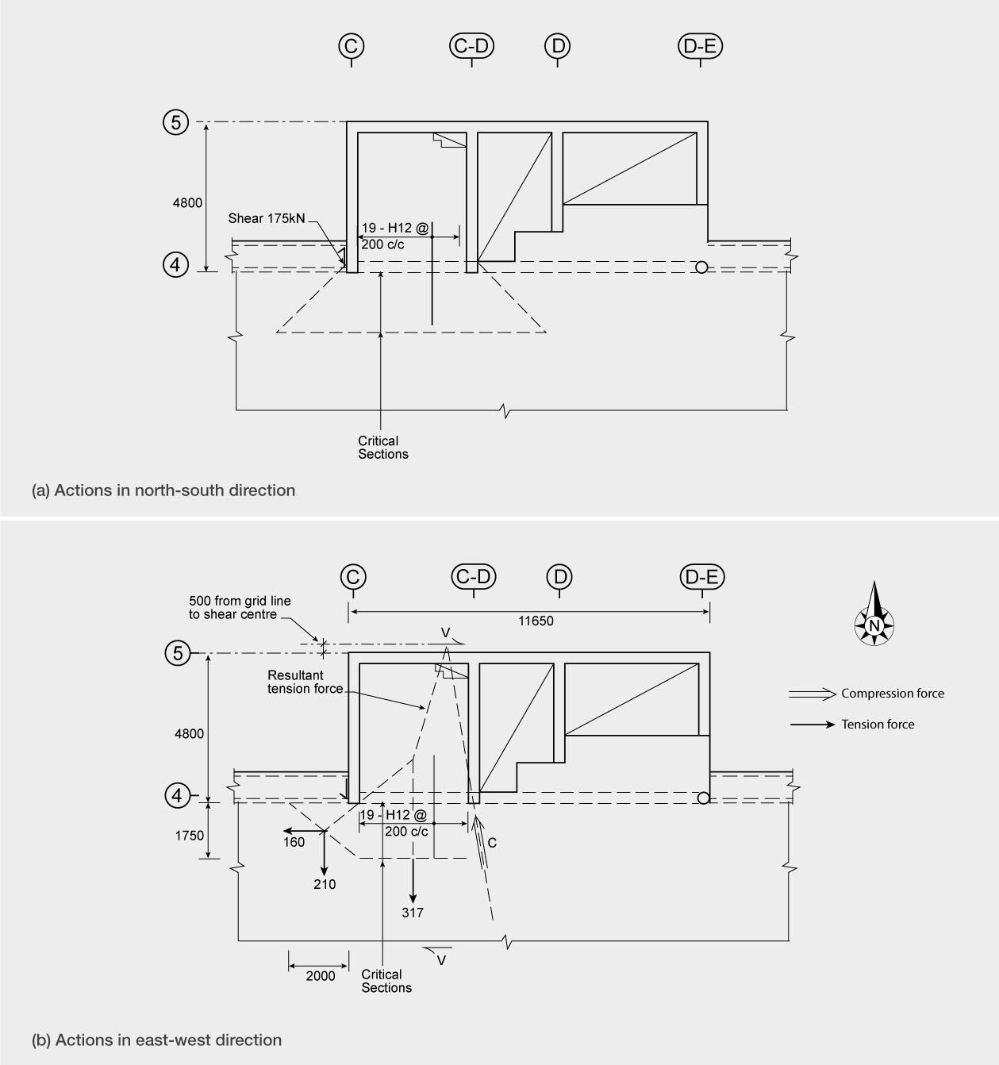

Figure 76: Connection of the floor at level 6 to the north wall complex

The second column of Table 2 has a list of the design tie forces for the different levels of the building in the north-south direction at line 4, as assessed by the Royal Commission using the parts and portions provisions in NZS 4203:1984. These values can be compared with the averaged peak forces predicted in the non-linear time history analyses2 for the September and February earthquakes. For the September earthquake the averaged predicted peak forces from the non-linear time history analyses at each level are for the recorded ground motions at the CCCC and CBGS stations. These values are listed in column 3 of the table and they are the average of the values for the forces to the north and to the south for both ground motions, giving an average of four values. In column 4 the corresponding values have been calculated for the February earthquake. However, in this case the predicted values from the non-linear time history analyses are for the ground motion records at the CCCC, CHHC, CBGS and REHS stations and consequently they are the average of eight values.

The table shows the predicted tie forces between the floors and the north wall complex do not appreciably decrease with the height of the floor, as is implied by the design forces calculated from NZS 4203:1984. For the September earthquake the tie forces in the lower three levels are approximately 70 per cent higher than the design values. For the February earthquake the predicted tie forces in the upper two levels are approximately 50 per cent greater than the design actions and the corresponding value for the lower three levels is 160 per cent.

Table 2: Connection forces (kN) of floors to north wall complex in north-south direction

Level Design forces 4 September 22 February
NZS 4203:1984 2010 2011
6 | 1225 | 1150 | 1760
5 | 1000 | 1410 | 1570
4 | 750 | 1290 | 1820
3 | 750 | 1500 | 2150
2 | 750 | 1060 | 1900

Figure 77(a) shows the variation of the predicted tie forces between the level 6 floor and the north wall complex in the north-south direction during the September earthquake for the ground motion recorded at the CBGS site. From the variation of tie force with time it appears that there are two different contributions. First, there appears to be a cyclic variation that has a period of the order of one and a half seconds. Secondly,
there are a large number of high frequency cycles. The fundamental period given in the non-linear time history analysis report is 1.3 seconds for vibration in the north-south direction. This suggests that the 1.5 second variation in tie force is related to the fundamental period, which may have been increased due to rocking on the foundation and/or stiffness degradation associated with inelastic deformation. The high frequency components are likely to be related to higher mode vibrations. It is evident from the figure that these higher mode components make up a considerable portion of the maximum force that is induced.

Figure 77(b) shows the corresponding variation of
the tie force for the February earthquake. However, in this case the periodic variation corresponding to the fundamental period of vibration is not as clear as it was for the September earthquake. This is likely to be due to the shorter duration of the very much stronger ground motion that occurred in the February earthquake, which would have increased the inelastic deformation compared to the September earthquake. However, the record still shows that there are a large number of high frequency vibrations occurring, which add considerably to the magnitudes of peak force transfer between the floor and the wall complex. In both earthquakes the higher mode contribution to the tie forces is significant.

6.3.3.2 Assessment of east-west design actions

As with the forces in the north-south direction the voids in the floors adjacent to the north wall complex prevent any significant transfer of force from the floor to the wall on line 5 in the zone between the walls C-D and D-E. Consequently the shear transfer between lines 4 and 5 is restricted to the floor slab between walls C and C-D. Allowing for the offset of 0.1b between the centre of mass and the assumed location of the resultant lateral force gives a design shear force at line 4 between the floor on level 6 and the north wall complex of close to 600kN (where b is the width of the building normal to the direction of seismic forces). We have again assessed this force using the parts and portions clauses in NZS 4203:1984. This shear induces bending moments acting in the plane of the slab. Consequently, the floor slab in the location close to line 4 and the walls C and C-D needs to be capable of resisting simultaneously a shear force of 600kN and the associated bending moment (equal to the shear force times the distance from line 4 to the shear centre of the north wall complex). The situation, and a method of assessing the capacity of the floor slab to resist these actions, is illustrated in Figure 76(b).

1600

6 17 18 19 20 21 22 23 24 25 26 27 28 29 30

1400

1200

1000

800

600

400

200
• • •• • •• • •••

Level 6 N/S

0

-200

16 17 18 19 20 21 22 23 24 25 26 27 28 29 30

-400

-600

-800

-1000

-1200

• •• • •• •••••••••

(a): September earthquake

3000

0 1 2 3 4 5 6 7 8 9

2500

2000

1500

1000

500
• • •• • ••• • •••••••••••

0
1 2 3 4 5 6 7 8 9

Level 6 N/S

-500

-1000

1500

-2000

2500

• •• • ••• •••••••••

(b): February earthquake

Figure 77: Predicted tie forces between the level 6 floor slab and the north wall complex at line 4 for the CBGS ground motion records in the north-south direction in (a) the September earthquake and (b) the February earthquake

As noted previously, the effective shear centre has been assumed to be located 0.5m to the north of line 5. For any chosen free body the bending moment and shear at a critical location can be considered to be equivalent to two resultant forces balancing the shear force of 600kN in the wall, as illustrated in Figure 76(b). Equilibrium requires that these two forces intersect the force resisted by the north wall complex at a single point.

To assess the strength of the connection between the floor and wall the critical sections have to be selected. One of these is along the south side of the beam on line 4 (see Figure 76(b)). With the shear force resulting from the floor moving to the west, the wall on line 5 applies a restraining shear force to the east. The bending moment acting at line 4 induces a compression force, which would act on the end of the wall C-D (as shown in Figure 76(b)), with a tension force acting in the slab. The beam framing into the wall C on the western side has some capacity to resist lateral forces due to the dowel resistance of the top bars that pass through the wall. This dowel capacity is assessed as approximately 175kN (using the current Concrete Structures Standard, NZS 3101:20063). The compression force in the slab near the end of the wall C-D would have prevented the reinforcement in the slab in this location from contributing to the tension force. To allow for this the tension capacity of the reinforcement within 0.5m of the wall C-D has been assumed to be ineffective.

Based on these assumptions the design bending moment capacity of the section at line 4 is approximately equal to 2200kNm, which corresponds to a shear force in the wall of 440kN. This is close to 70 per cent of the design value if the interaction of flexure and shear is neglected.

A separate check for shear is required at the section adjacent to the beam on line 4. The design action shear stress is found (using NZS 3101:19824 by dividing the shear force of 600kN by the strength reduction factor
of 0.85 and by the area (bwd), where the effective depth, d, is taken as 0.8h, where h is the length of slab (3.55 + 2 x 0.3) from outside to outside of the walls
C and C-D, and bw is the minimum thickness of the
slab, which in this case is 150mm). The resultant shear stress is 1.42MPa. As this is not a beam, the shear resisted by the concrete should be taken as zero and reinforcement is required to carry a force of 600kN. The available reinforcement, 664 mesh and 19 x 12mm high-strength bars have a capacity of 1133kN, which exceeds the required design action. The shear stress at this level is not critical. However, as noted above, the interaction of flexure and shear reduces the flexural capacity calculated above. Consequently the design
strength of 70 per cent of the design action should be taken as an upper limit.

A second critical section is close to the termination position of the 12mm bars placed over the beam on line 4. The critical section is taken at a distance of 1.75m to the south side of line 4. As the mesh to the west of line C laps into the 12mm reinforcing bars, some of the tension force carried by the mesh can be transferred to these 12mm bars. To allow for this effect the critical section is assumed to extend from the end of the line where the 12mm bars are terminated, to the junction between the slab and the beam on line 4 to a point 2m west of the wall C. This section is shown on Figure 76(b). As in the previous case it is assumed that reinforcement within 0.5m of the compression force is ineffective. Elsewhere it is assumed that mesh crossing the critical section is stressed to its design level of 485MPa (0.2 per cent proof stress). The resultant tension forces carried across the different portions of the critical section are combined to give a single resultant tension force, as shown in Figure 76(b). From the resultant forces and their angles, the magnitude of the shear force that can be resisted is found to be approximately 40 per cent of the design value of 600kN. It should be noted that this assessment ignores any contribution that may arise from the tensile capacity of the Hi-Bond tray, which may or may not contribute to the strength depending on how effectively the concrete was bonded to the tray.

Both Professors Nigel Priestley and John Mander indicated that it looked as though the floors in the location of walls C and C-D were inadequately reinforced to resist the shear and flexural actions in this region. However, they did not report on any numerical assessment that they may have made to support their deductions. Mr Banks stated that he had assessed the flexural strength. The bending moment capacity that he calculated (1800kNm) was approximately 60 per cent of the design action.

Table 3 gives the design shear forces at line 4 between the floors and the north wall complex at each of the levels for the east-west direction. These values may be compared to the averaged predicted peak shear forces found in the non-linear time history analyses2 for actions to the east and to the west. For the September earthquake the analyses were for the CCCC and CBGS ground motion records. Hence the value recorded in the table is the average of four values. For the February earthquake analyses were made for the ground motion records from the CCCC, CBGS, REHS and CHHC sites. In this case the averaged value in the table is therefore based on eight values.

Table 3: Connection forces (kN) of floors to north wall complex in east-west direction
either by yielding in shear of the bolts or by tensile
failure of the concrete reinforced by brittle mesh. Ductile behaviour could have been obtained by connecting each of the walls C, C-D, D and D-E to the floors by three high-strength (380MPa) 20mm bars, which could have been anchored into the walls and extended into the floor almost to line 3. If this detail had been used it is probable that separation between the floor and walls would not have occurred even though the strength of these bars would be of a similar magnitude to that of the drag bars.

Level Design forces 4 September  NZS 4203:1984 2010 |  |  | 22 February  2011
6 | 600 | 1050 | 2170
5 | 490 | 830 | 1870
4 | 370 | 790 | 1820
3 | 370 | 720 | 1690
2 | 370 | 500 | 1310

It is clear from the table that the peak forces connecting the floors to the north wall complex for the east-west direction were considerably in excess of the design actions. Typically, the September earthquake values were about 1.75 times the design action, while the corresponding values for the February earthquake were four times the design actions.

As in the north-south direction the variation in tie forces in the east-west direction for the September and February earthquakes appears to be made up of a cyclic variation in tie force, which appears to have a frequency of about 0.4 seconds, together with further high-frequency components (see Figures 78(a) and (b)). It is anticipated that the frequency of 0.4 seconds is related to the natural period of the north wall complex acting in the east-west direction.

6.3.3.3 General comments on tie forces

From Figures 77 and 78 it is apparent that the high- frequency components of the tie forces between
the floors and the north wall complex make up an appreciable proportion of the maximum values. The high frequency components are associated with small displacements; consequently, limited ductile behaviour in the ties could significantly reduce the design magnitude of the tie forces. The drag bars would have had very limited ductile capacity as failure would occur

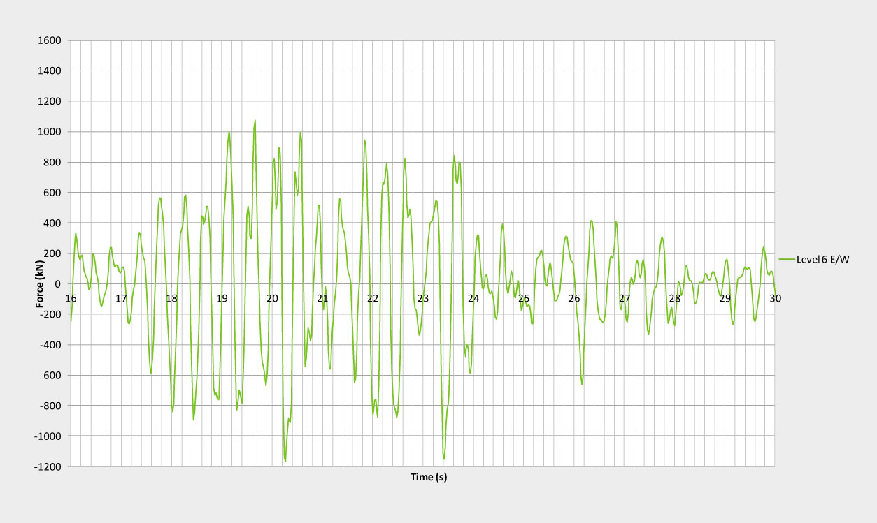

(a): September earthquake

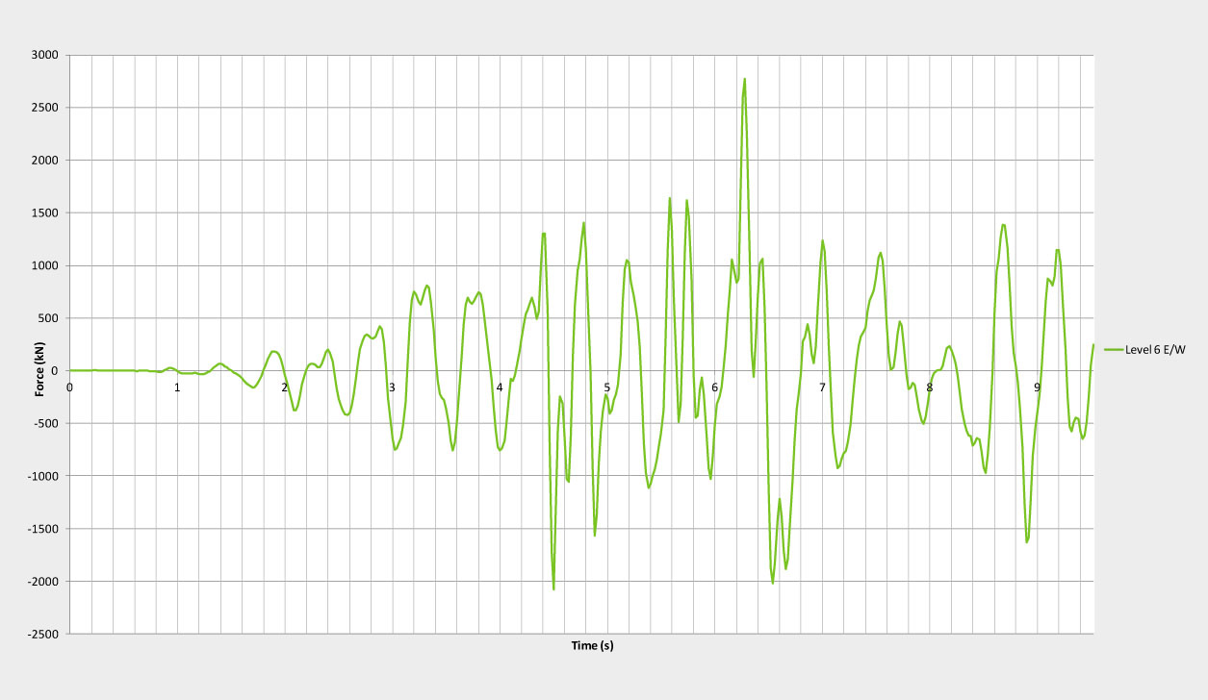

(b): February earthquake

Figure 78:Predicted tie forces between the level 6 floor slab and the north wall complex at line 4 for the CBGS ground motion record in the east-west direction for the (a) September earthquake and (b) the February earthquake

6.3.3.4 Warping of north wall complex and interaction of wall D-E with the column C18 in level 6

The bending moments induced in the floor due to seismic forces acting in the east-west direction cause the wall on line 5 to rotate relative to line 4. This rotation results in warping of the wall, which is illustrated in Figure 79. This action induces out-of-plane bending moments in the wall on line 5. Lateral forces are also induced in the finger walls D and D-E and in the connections between these walls and the floors. The out-of-plane bending moments in wall 5 account for the

vertical cracks which were found by Mr Graeme Smith in the wall on line 5 in the lift shaft.

Between levels 4 and 6 the floors and drag bars restrain lateral movement of the wall D-E. However, no such restraint occurs at level 7, which is at the roof level. At this level the lateral movement of the wall D-E induces lateral displacement and the associated bending moments and shear forces on column C18, see Figures 79 and 80.

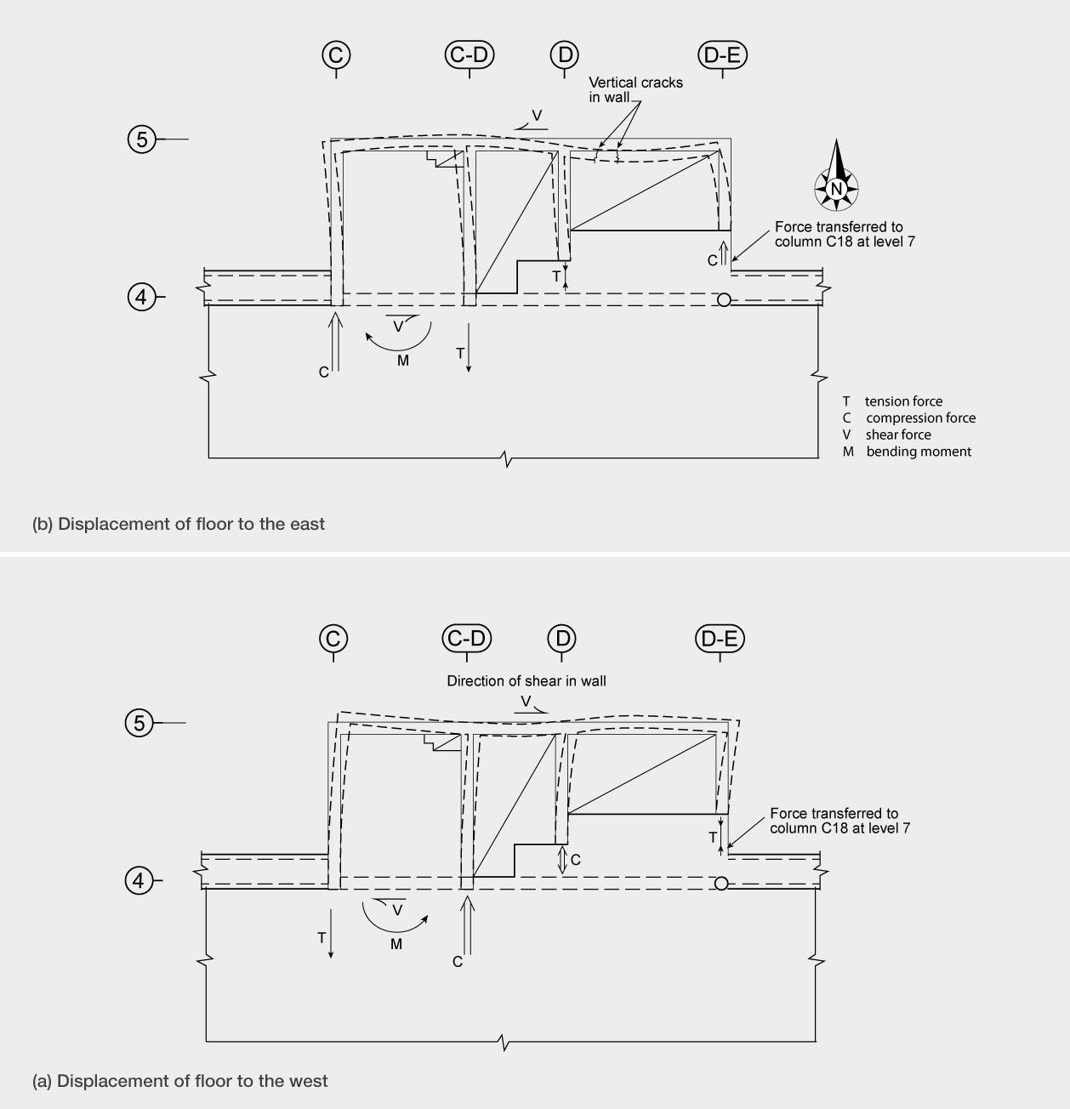

Figure 79: Warping of north wall complex

Failure due to anchorage of bars close to lower edge

7

Column in tension due to sway to the north

6

5

3

2

1

Elevation of wall D - E

Figure 80: Deflected shape of wall D-E

The wall D-E is tied into the column C18, as shown in Figure 80. Bending of the wall D-E due to seismic actions in the north-south direction would induce axial forces in the column which, combined with the warping action described in the previous paragraph, accounts for the observed cracking in the column C18 on level 6.

The connection between the column C18 and the wall D-E was poorly detailed with the bars from the column being bent into the wall close to the lower surface of the wall at level 7 (see Figure 80). Any appreciable tension in these bars would result in the portion of wall shown in the figure being pulled out of the wall. It is likely that this was the source of the damage observed by Mr Coatsworth and Mr Leonard Pagan after the September earthquake and by Mr Peter Higgins after the Boxing day earthquake. This damage can be seen in Figures 50(a) and (b) in section 3.6.7.2 of this Volume.
6.3.4 South structural wall

The south structural wall was designed as a coupled shear wall as shown in Figure 81. The wall was nearly 20m high and it consisted of two walls each measuring 2050mm in length and 400mm in width, which were connected by coupling beams with a length of 900mm. The gap below each coupling beam was used as a doorway with a height of 2050mm, giving access to stairs for emergency egress on the outside of the building.

Reinforcement symmetrical in each wall and both walls identical
Actions on one wall |  |  | Coupling beam shears
(a) Axial load (kN) | (b) Tension force (kN) | (c) Sum (a)+(b) (kN) | (d) Diagonal bars  (kN) | (e) Floor slabs (kN) | (f ) Sum (d)+(e) (kN)
58 | (688)2  9171 | 746  975 | 346 | 171 | 517
290 | (688)  917 | (978)  1207 | 835 | 413 | 1248
522 | (974)  1490 | (149)  2012 | 1324 | 655 | 1979
754 | (1318)  2178 | (2072)  2932 | 2028 | 897 | 2925
986 | (1671)  2884 | (2657)  3870 | 2986 | 1139 | 4125
1224 | (1671)  2884 | (2895)  4108 | 4109 | 1381 | 5490

Height (m)
19.90

4-D20
Level
7

16.66 6
3-H16

4-D20
3-H16

13.42 5

4-D20

10.18 4
3-H24

4-D24
5-H24

6.94 3

4-D28
5-H28+1-H12 5-H28+1H12

3.70 2

4-D28
6-H16 (2x3)

A A
0 1

Elevation - South wall

6-H16
400
5-H28
+1-H12
5-H28
+1-H12

1 Maximum possible axial tension force in one wall
2 Maximum tension force without extensive redistribution of bending moments

6-H16
5-H28
+1-H12
5-H28
+1-H12

2050 900 Reinforcement at one end of wall
Section A - A

Figure 81: The coupled shear wall on line 1

Coupled structural walls are intended to dissipate seismic energy by forming plastic hinges at the base of each wall and by plastic deformation in the coupling beams. However, photographs and sketches in the Hyland materials report5 of the wall show less damage to the coupling beams occurred than would be anticipated given that the non-linear time history analyses2 predicted inter-storey drifts in excess of 2.5 per cent. From the Hyland materials report it is apparent that extensive yielding occurred at the base of the wall, where at least one 28mm bar necked and fractured. In addition there were significant diagonal cracks in the walls close to the base. There were also diagonal cracks in the coupling beam immediately below level 3 and in the walls between levels 2 and 3. There was little apparent damage to the coupling beams above level 3, though there were a few flexural shear cracks in the walls.
The Hyland materials report indicates that many of the beams on line 1 separated from the wall with either the bars anchoring the beam to the coupled wall being necked and fractured, or the beam and bars being pulled out completely from the wall.

The wall can only behave as a ductile coupled shear wall above the level being considered if the sum of the shear capacities of the coupling beams above the level is less than the sum of the axial loads acting above the level plus the tension force that may be resisted in one of the coupled walls at the level being considered. To check this condition the axial load acting on each wall was calculated for the dead and seismic live loads from the tributary areas. The maximum axial tension is limited by the sum of the maximum force that can be resisted by the longitudinal reinforcement in a wall.

However, for all the reinforcement to yield in tension, extensive redistribution of bending moment must take place. This level of redistribution is unlikely to occur. Without this extensive redistribution of bending moment the reinforcement on one end of the wall (see Figure 81) will be in compression or sustaining negligible tension.

The table within Figure 81 summarises calculations made by the Royal Commission on the likely performance of the south shear wall. Two conditions have been considered: first, where all the reinforcement in one wall is at yield in tension, and secondly where all the reinforcement is in yield in tension except for the reinforcement at one end of the wall. The table contains the following items:

a) The sum of the axial loads on one of the walls above the level being considered. These values were calculated from the tributary areas for the dead and seismic live load. Any change in axial load due to vertical ground motion has been neglected as the rapid increases and decreases in axial force tend to cancel each other out.
b) The maximum tension force in the wall at the level being considered based on the assumption that all the reinforcement in the wall is in tension at its design yield stress. The value in brackets is the tension force neglecting the reinforcement at one end of the wall. This represents the case where extensive moment redistribution has not occurred. For example, below level 3 the tension force for this case excludes the reinforcement group of 5-H28 + 1-H12 bars.
c) This column contains the sum of columns (a) and (b). d) The sum of the shear forces in the coupling beams
above the level being considered is given in this column. These calculations are based on the yield forces resisted by the diagonal reinforcement.
e) This column gives an assessment of the contribution to the shear resistance of the coupling beams, which arise from the floor slabs being tied into the coupled walls. This is explained in greater detail in a later paragraph.
f) This column contains the sum of the values in columns (d) and (e) to give the resultant sum of coupling beam shear forces above the level being considered.
As noted previously, the coupling beam cannot yield to any appreciable extent at a level if the value in column (f) exceeds the corresponding lower value in column (c), and significant yielding in the coupling beam is unlikely if the value in column (f) exceeds the bracketed value in column (c). It has been, and still is, standard practice to calculate the shear capacity of diagonally reinforced coupling beams from the forces that can be carried by the diagonal bars acting at yield in tension and compression. With the two sets of diagonal bars the diagonal tension and compression forces are equal and consequently no axial load is assumed to act on the coupling beam. However, this is often not the case.

As shown in Figure 82, once flexural cracks form in the coupling beam elongation occurs. If floors are connected directly or indirectly to the coupled walls they apply lateral restraint to the walls. The restraining tension force induced in each floor applies a corresponding compression force in the coupling beam. Professor Mander agreed that this action would occur. As illustrated in Figure 82(b), this increases the shear capacity of the coupling beam, with the axial force increasing the diagonal compression force in the coupling beam.

Tension resisted

by floor slab

Coupling beam

(a) Plan of wall section and floor slab

Diagonal compression force due to tension resisted by floor slab

Elongation

(b) Elevation of coupled wall and coupling beam

Figure 82: Elongation of coupling beam and interaction with floor slabs

The slab in the east-west direction was reinforced
by 664 mesh. Due to this low reinforcement content, when the floor was subjected to axial tension, cracking would have been limited to a single crack, with the reinforcement yielding at this one section. Consequently, due to tension stiffening of the concrete the floor would have acted as a stiff tie with a lateral tie force limited by the yield capacity of the 664 mesh. To assess the significance of the restraint force on the coupled wall it has been assumed that the tie force in the slab is limited to the tension capacity of the mesh in half of the 7.5m span of the slab between lines 1 and 2 (a distance of 3.75m) stressed to its 0.2 per cent proof stress of 485MPa. Using this force, the added shear capacity of the coupling beams can be assessed by assuming that the diagonal force due to axial load forms at the same angle as the diagonal compression force in the coupling beams.

When a check was made for these conditions at the base of the wall it was found that the sum of the shear capacities of the coupling beams was marginally higher than the axial load and the tension capacity of
all the longitudinal reinforcement in the wall. This indicated that below level 2 the coupled wall would act as a single unit. The damage at this level is consistent with this prediction. However, when the criterion was applied at level 2 and above it indicated that coupling beams might yield, but only if extensive redistribution of bending moment occurred.

We conclude that extensive yielding of the coupling beams would not have occurred and the coupled wall would have acted predominantly as a single unit. A limited amount of yielding may have occurred in the coupling beams at levels 3 and 4 and in higher mode actions, but this yielding would have been limited. The consequence of this is that the wall would have been stronger than assumed in the design but it was less able to dissipate energy than implied by NZS 3101:1982. The increased energy dissipation in coupled walls is recognised in the Standard by the use of the structural type factor of 0.8 instead of 1.0 for a ductile wall. In retrospect, the use of the 0.8 was not appropriate for this case. However, there were no criteria in the design standards and text books at the time that would have indicated that the coupling beam strengths were too high.

Our previous Recommendation 47 in Volume 2 is for structural designers to develop a greater awareness of the interaction between elements due to elongation, and for guidance on these matters to be given in the commentary to the Standard. We note that the potential restraining effect of floor slabs on coupled shear walls, as described above, is an example of such an interaction.

6.3.4.1 Assessment of south shear wall design actions
Table 4 lists the lateral design tie forces between the floors to the south shear wall. These values have been assessed by the Royal Commission using the parts and portions section of NZS 4203:1984. As in the case of the north wall complex, the seismic weight of the floor from line 4 to line 1 was assessed as 4900kN. Allowing for the 0.1b offset, which includes an allowance for accidental torsion, 68 per cent of the lateral force due to this mass would act on the south shear wall. The forces relate to the tie actions between the south shear wall and the floor which act across the interface between the wall and the floor. Any contribution due to the weight of the floor, between lines 4 and 5 would have been minimal due to its closeness to the wall on line 5 and the torsional resistance of the walls C, C-D, D and D-E.

The peak connection forces from the non-linear time history analyses2 are listed in the table in the third and fourth columns. These values were found following the steps described for the corresponding actions for the north wall complex.

The predicted tie forces for the September earthquake are on average 10 per cent higher than the design actions. However, unlike the design actions and the corresponding values for the north wall there is no significant decrease in magnitude with the height of the floor in the building. The corresponding values for the February earthquake are on average 90 per cent higher than the design forces. The predicted magnitudes of the average peak tie forces between the floors and the south shear wall increased as the height of the floor in the building reduced. This is opposite to the trend in design actions and predicted tie forces for the north wall complex. While the parts and portions design forces are higher for the south shear wall than for the north wall complex the predicted values from the non-linear time history analyses are smaller. This is almost certainly related to the longer natural period of vibration of the south shear wall compared to the north wall complex.
Table 4: Connection forces (kN) of floors to the south wall

Level Design forces 4 September 22 February
NZS 4203:1984 2010 2011
6 | 840 | 630 | 1030
5 | 680 | 770 | 1160
4 | 510 | 670 | 1080
3 | 510 | 700 | 1210
2 | 510 | 620 | 1410

6.3.4.2 Connection of floors to south shear wall

In the 5m length of the south shear wall at each floor level there were five metres of 664 mesh and eight H12mm bars to tie the floor into the wall. The design of this interface could be based on shear friction as detailed in NZS 3101:1982 with a friction coefficient of 1.4. The total tension capacity of the reinforcement between the wall and each floor based on the design yield strength of the reinforcing (fy 380MPa) bars and the 0.2 per cent proof stress in the mesh (485MPa) is 790kN. With the shear friction coefficient of 1.4 and the strength reduction factor of 0.85 the design interface shear strength is 940kN. This value exceeds the maximum design value. If, instead, the critical section is taken in the slab where the 12mm bars are terminated, the strength over the five metre length decreases to 45 per cent of the maximum value. However, adequate additional capacity can be developed by transferring the shear force to the perimeter beams on line 1 provided these beams are adequately tied into the coupled wall.

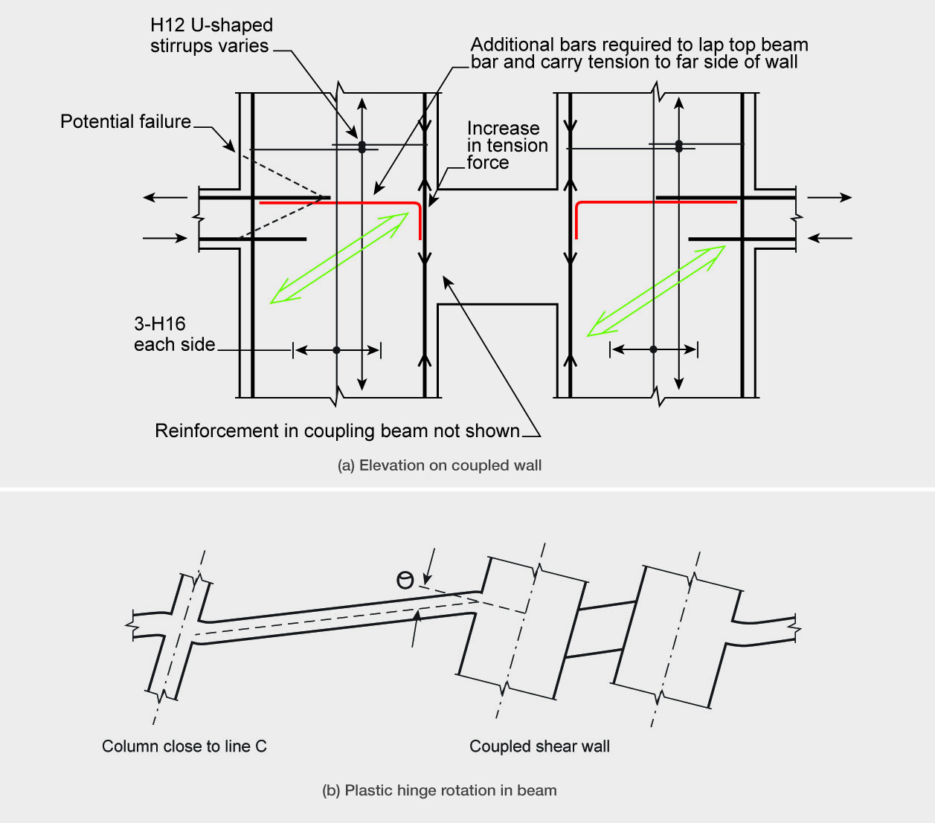

Figure 83: Coupled shear wall and anchorage of beams framing into the wall

The beams on each side of the coupled wall on line 1 are tied into the wall by five 24mm bars, with three at the top of the beam and two at the bottom. The design yield strength of this reinforcement is 380MPa. The span of the beams between the end of the coupled wall and the adjacent columns on line 1 is 7.5m. The flexural strength just meets the gravity load case (of 1.4D and 1.7L). The development length for the top bars meets the specified length given by NZS 3101:1982. However, the bars are anchored in the wall near the location where they entered the wall. The tension force carried by the reinforcement should be carried to the far side of the wall from where it entered the wall. This arrangement enables the tension force to be anchored by diagonal compression forces in the concrete and a vertical force in the wall resulting from a change in the magnitude of either the flexural tension or flexural compression force, as illustrated in Figure 83(a). An alternative to extending the beam bars is to
add additional reinforcement, which laps the beam bars and enables the tension force to be carried to the far side of the wall. Without this additional reinforcement there is the possibility that the beam bars will be pulled out of the concrete. Where it is anchored in the wall the beam reinforcement will generate tensile stresses in concrete, which may be expected to initiate diagonal cracks in the concrete.

Figure 83(b) shows the deformed shape of the wall and beams framing into it. The flexural rotation of the coupled wall increases the plastic rotation induced at the end of the beam by about 40 per cent. This added plastic hinge rotation occurs due to the lack of local elastic rotation in the wall relative to the columns, and the increased vertical movement of the end of the beam due to the flexural rotation of the wall. The increased plastic hinge rotation, which is shown in Figure 83, adds to the anchorage problems of the beam bars in the wall.

There is one further problem that arises at the junction
of the wall and precast beams. The beams were detailed as 960mm wide and the corresponding wall dimension was 400mm. As the inside faces of the beams and wall were in line there is an eccentricity of 280mm between the two of them, which would result in local torsional actions being induced in the wall and lateral bending in the beam. The high plastic hinge rotations induced with east-west inter-storey drifts and the local twisting action may have reduced the anchorage strength of the bars in the wall. This may have contributed to the observed separation of the beams and coupled shear wall in its collapsed state.

6.3.5 Gravity load system

Typical details of the beams and floor slab (which was constructed by casting 200mm of concrete reinforced with 664 mesh on a Dimond Hi-Bond metal tray) are shown in Figure 84. The clear span of the floors was 7.1m, which, as we have earlier noted, was approximately 500mm in excess of the recommended maximum span (Dimond Hi-Bond technical literature). To compensate for the extra 500mm, 12mm high strength bars were placed over the beams at 120mm centres. There was no direct reinforcement tie between the beams and the floor slab and consequently, in the event of partial loss of support, the beam and associated floor could separate. This detail is not robust and it is possible that this contributed to the
progressive collapse of the building.

H12mm at 120 c/c
A 664 mesh

200

350

10mm stirrups

Hi-Bond tray Section A-A A

60
400

Figure 84: Typical details of floor slab and support beams

Precast beams were supported on cast in situ columns
as shown in Figure 85. The columns on lines B, C,
D, E and F were circular in section with a diameter of
400mm, and they were reinforced by six high-strength
20mm bars confined with 6mm spiral at a pitch of
250mm. The columns on line A were rectangular in section with dimensions of 400 x 300mm with the 400mm dimension parallel to line A. Ties in these columns consisted of 10mm bars at 250mm centres.

Beam wing
Cracks at base of beam

25mm
seating

Smooth interface

200mm approx

Figure 85: Plan of precast beams supported on an internal column

The ends of the precast beams were shaped to enable them to be supported on the circular columns as simply supported members during construction, as shown in Figure 85. The part of the beam between the circular shape for the column and the edge of the beam is referred to as a wing. There was no reinforcement to tie the wings into the beams. With this arrangement the beams had a 25mm support length on cover concrete. In most of the beams the bottom longitudinal reinforcement consisted of four high-strength 28mm bars. Two of these bars were terminated just short of the columns and the other two were hooked so that, when the columns were cast, they were anchored in the in situ concrete. These details are shown in Figures 87, 88, 89 and 90. In some of the shorter beams a lesser amount of reinforcement was used in the precast beams. However, in all cases the bars that extended into the beam-column joint zone were hooked in the in situ concrete.

As discussed in section 5.1, inspection of the CTV site after the collapse, and of the building debris at the Burwood landfill where it was stored, showed that in all cases the wings of the precast beams had broken off (see Figures 85 and 86). Inspection of the ends of the beams showed that the interface between the precast beam and in situ concrete in the column was smooth, with no adhesion between the precast and in situ concretes (see Figure 86). Mr Frost suggested that the wings could have broken off due to radial pressure between the column and the end of the beam (see section 5.1.3.3). Cracks may have been initiated by radial pressure between the beam and column due to negative moments generating a flexural compression, applying a compression force across the interface. Alternatively, thermal expansion of the concrete associated with heat of hydration when the column was cast, or the Poisson expansion of the column concrete, associated with the axial load and creep, may have generated pressure that initiated the cracks.
Photographs show that typically when the beam wings had fallen off, the remaining interface between the column and beam had a width of about 200mm.

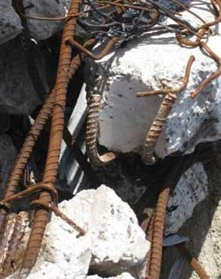
Figure 86: Photo of end of beam

Figure 87 shows the structural details and potential failure mechanisms associated with an internal beam column support. Parts (a), (b) and (c) of the figure show a plan view and a sectional elevation of the joint zone and a beam section. Of the four 28mm bars at the bottom of each beam only two extend into the joint zone. This reduction in reinforcement close to the column face concentrates any positive moment flexural tension force into two bars which, as detailed, have just under 60 per cent of the development length required for full strength. With this arrangement any positive moment inelastic deformation in the beam could lead to rapid strength degradation of the joint zone.

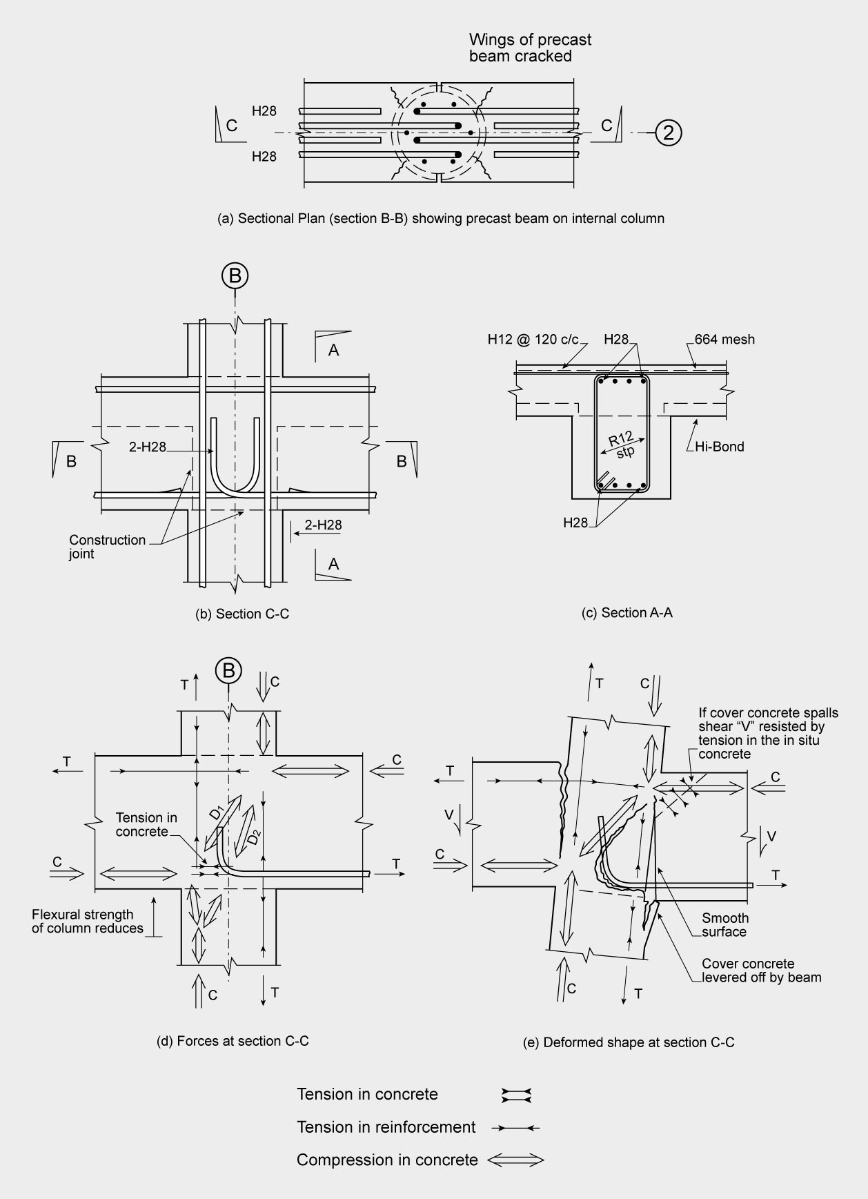

Figure 87: Junction of internal beams and column

Part (d) of Figure 87 shows the track of the forces through the joint zone and the adjacent regions of the beams and columns. Any flexural tension force in the right hand side beam acts on the hooked bars, which extend to the mid-zone region of the joint. Any tension in this bar is resisted by tension in the concrete behind the bar. Once a crack forms due to this tension force the diagonal compression force, shown as D2 in the figure, can develop from the upper compressed corner of the joint into the hook. To satisfy equilibrium requirements a vertical force is required from the lower column to balance the vertical component of the force D2. To provide this force the centroid of the compression force in the lower column must move towards the centre of the column (see part (d) of the figure). This results in a reduction of the flexural strength of the column, close to the interface with the beam soffit, of the order of 10–20 per cent. As a result, any inelastic deformation in the column is confined to the joint zone and the immediate vicinity of the column interface with the beam soffit. In effect the joint zone is weaker than the column. Professor Mander came to the same conclusion. As a consequence, the joint zones could be expected to degrade in strength and stiffness before the columns developed plastic hinges.

Part (e) of Figure 87 shows two potential failure mechanisms for the internal beam-column joints.

1. Once the concrete behind the hooked bar cracks in tension there is little to stop the hooked bar pulling out of the concrete as the diagonal compression force “D2” forms at an angle that is too steep to be effective. The anchorage failure of the hooked bar is associated with the development of a wide crack through the joint zone as shown in part (d) of the figure. This degrades the strength of the joint zone and a reversal of actions could be expected to destroy the joint zone.
2. The beam is supported on a 25mm width of cover concrete. If the wings have broken off, as described previously, the effective bearing area is on a width of 25mm and a length of approximately 200mm (see Figure 85). The gravity load due to self-weight of the slab and beam, the added dead load and a nominal live load results in a contact force of approximately 160kN. The resultant contact average stress due to this load is close to 30MPa, which is at a level close to the failure load. This stress level could have been significantly increased by vertical seismic ground motion. If a positive moment acts on the beam a crack could open up at the smooth interface between the beam and the column. The opening up of this crack to even a small width may result in the
cover concrete being levered off from the column,
as shown in part (e) of Figure 87. As no shear can
be resisted across the smooth crack the shear force is transferred to dowel action of the hooked bars at the bottom of the beam, and to tensile resistance in the in situ slab concrete at the top of the beam. Appreciable deformation is required to develop dowel action and, as one of the bars is relatively close to the free edge of the column, it is unlikely that appreciable dowel action could be sustained. The shear resistance provided by tension in the slab concrete is a brittle action. Consequently, the capacity of dowel action and the tension capacity of the concrete in the slab cannot be added together. The shear force in the beam is resisted by the web, which has a width of 400mm. If the shear force is resisted by tension in the slab an effective width of slab is likely to be of the order of 500mm, which is 100mm wider than the width of the web. Four 28mm top bars pass though this region, reducing the effective width of slab that could resist the tension to about 400mm. Based on this width the diagonal tension stress in the concrete required to resist the gravity load (of 160kN) is of the order of 2MPa. The design direct tensile strength given in NZS 3101:2006 is 1.8MPa for 25MPa concrete and it is used with a strength reduction factor of 0.6. Consequently a direct tensile strength of the order of 2MPa is close to a condition where failure would be expected to occur. If allowance is made for vertical seismic ground motion, the tensile stresses are likely to increase into the range where failure would be expected, and this would result in collapse of the beam. Mr Frost postulated a similar collapse mechanism.

1 A

C D
25
A
B B
300
160
140

R10 @ 200

Floor on
Hi-Bond

Cjt

Precast beam

Precast
E E beam

2 H24

C
400 D

(a) Section A-A Plan on Junction of precast beams on column
(e) Sectional Elevation D-D

1

D
H20 A

A H24
R10@250 c/c

A

2-H24
H24 + H12

H12

Cjt

D
R10@250 c/c

(b) Section B-B Junction of beam on line A with column

2-H24

C

Tension in concrete

(f) Section C-C Junction of beams on line 1 with column
T

Block wall under beam not shown

(c) Section B-B Deformed shape

1

Tension in concrete

Precast beam

T C

(d) Sectional Elevation E-E
(g) Section C-C Deformed shape

Figure 88: Junction of beam and column at south-east corner of building

Figure 88 shows the details and structural actions in
the beam-column joints in the south-west corner of the building, which was at the intersection of lines A and 1. Many of the structural details and associated actions illustrated in this figure apply to the other beam column joints on line A.

Figure 88(a) shows a sectional plan of the intersection of the precast beams with the column. The precast beams on line A were associated with a concrete block wall, which extended to level 4 (above this level there were no precast beams on this line). The drawings show that concrete blocks were tied into the beams by starter reinforcement above the beams on levels 2 and 3; by reinforcement which extended from anchors mounted in the soffits of the precast beams at levels 2 and 3; and from the soffit of the slab at level 4 into the concrete blocks. It is not clear how this reinforcement was placed. The top layer of blocks was not filled with concrete to allow relative lateral movements to occur between the top of the walls and the beams.

The lack of damage to the block wall as a result of
the September earthquake indicated either that it was effectively isolated from the structural members for this event or that it restrained movement in the north-south direction. However, in the February earthquake greater inter-storey drifts were induced and the extent to which the wall on line A would have restrained inter-storey
drifts before collapse occurred cannot be established with any level of certainty.

Figure 88(b) shows the reinforcement details of the intersection of the precast beams at levels 2 and 3 and the corner column. One high-strength 24mm bar extended from the bottom of the beam into the column where it was anchored by a hook just short of the mid-section of the column. This gave a development length of approaching 60 per cent of that required by NZS 3101:1982. The top reinforcement consisted of one 20mm high-strength bar. In addition there was some limited tensile capacity provided by the mesh reinforcement in the slab, which was tied into the beam by plain round 10mm bars (fy 275MPa) at 200mm centres. Part (c) of the figure shows the seismic actions and potential failure mode due to drift in the north-south direction. Parts (d) and (e) of the figure show details of the beam sections which are supported by the column. Parts (f) and (g) show the reinforcement details and failure mode at the intersection of the beam in the
corner column for seismic actions associated with inter- storey drift in the east-west direction. When significant flexural tension is applied to either the top or bottom reinforcement in the beam, the concrete behind the bar hooks is subjected to tension and it will crack allowing the hooked bar to pull out of the concrete. Clearly there is the potential for either or both of the beams on lines 1
and A to tear the joint zone apart.

B B

(b) Junction of beams on line A with column (c) Deformed shape of section A-A

2

A
A A

Section B-B

(a) Plan of precast beams and beam-column joint at A-2

Figure 89: Junction of beams on lines 2 and 3 with external column on line F

Figure 89(a) shows the intersection of the beams on line A at levels 2 and 3 with the beams on lines 2 and 3. Single hooked bars in the precast beams in line A extend to 15mm short of the column centre-line as shown in part (b) of the figure. The bottom bar in each beam has a diameter of 24mm and the top bar 20mm. Under the action of sway in the north-south direction negative moments are induced in one of the beams and positive moments in the other. Tension would have been induced in the concrete immediately behind the bottom bar, which is resisting a positive moment, and behind the top bar that is resisting a negative moment. The concrete would crack and the joint zone ties of R10 bars at 250mm centres, giving a maximum number of two ties, would not have been anywhere near adequate to prevent the hooked bars pulling the joint zone apart, as shown in part (c) of the figure. Rapid strength degradation would occur. The only feature that could have prevented collapse of these joint zones in the north-south direction would have been sufficient strength and stiffness in the concrete block wall to prevent appreciable inter-storey drift from developing at the columns on line 1. However, we consider that is unlikely to have been the case. It may also be noted that the opening up of the cracks in the joint zone due to sway in the north-south direction would have caused elongation, which would have added to the deformations imposed on neighbouring beam-column joint zones.
The situation described above is particularly critical as the strength of the columns is considerably greater than that of the beams and this would have forced inelastic deformation into the beams. The actions in the joint zone associated with the beams on lines 2 and 3 for inter-storey drifts in the east-west direction are very similar to those described in Figure 88.

Figure 90 shows the structural details and structural actions at the beam-column joints on line F at the intersections with grid lines 2 and 3. Part (a) of the figure shows a plan of the reinforcement in the precast beams and how this reinforcement is anchored into the column. All the longitudinal reinforcement in the bottom of the beams on line F is terminated short of the column centre line. Parts (b) and (c) in the Figure show cross- sections, which identify the locations of the principal longitudinal reinforcement in the beams. The top reinforcement along line F is continuous over the column.

The beam bars from the beams on line 2 and 3 were extended through to near the far side of the column (see Figure 90(b)). With this arrangement the joint zone should be capable of sustaining a few cycles of inelastic loading without loss of axial loading capacity for sway in the east-west direction, provided the joint zone is not degraded by actions associated with north- south sway.

The precast beams on line F were placed so that there was a 20mm gap between the ends of the two beams (see Figure 90(a)). This gap, whether filled with concrete or not, would have acted as a crack initiator, with the crack extending through the column centre-line as shown in part (d) of the figure. Such a crack could be initiated by wind or seismic actions, or it could have been present from shortly after construction due to shrinkage of the concrete due to thermal contraction associated with heat of hydration.

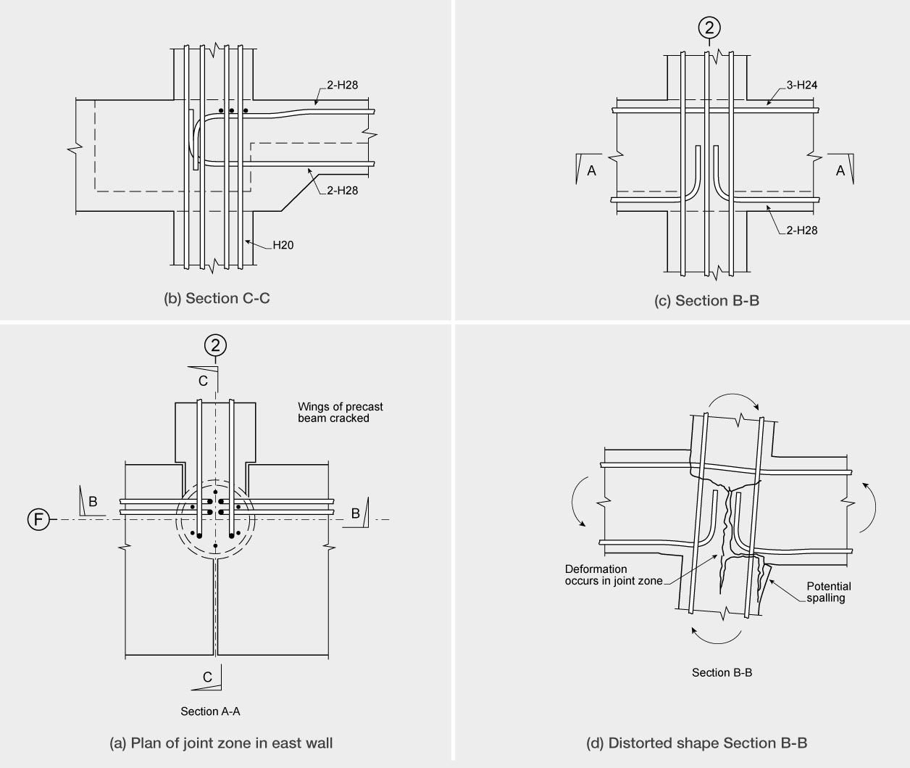

Figure 90: Intermediate beam-column joints on line F

Any tension force resisted by reinforcement in the bottom of the beam could be expected to extend the crack between the ends of the precast units into the column centre line. It may be noted that the column acts to lever the two beams apart and in the process creates a wide crack in the joint zone. This would result in strength degradation and the bars pulling the joint zone apart, as illustrated in Figure 90(d).
6.3.6 Answers to questions sent out to technical witnesses in the minute of
27 June 2012

As mentioned in section 6.3.2 experts giving evidence
to the Royal Commission on the collapse of the building were requested to consider a number of questions related to the structural performance of the north wall complex and the south shear wall. There was a limited response to these questions. However, in the assessment of the structural performance of the building several of the aspects were assessed by the Royal Commission. This section summarises the responses received and the additional conclusions we have arrived at due to our own study of the issues. In several cases more detailed information on these issues may be found in the discussion already set out above in this section.

6.3.6.1 Questions related to the south shear wall

a) Would this wall have behaved as a coupled wall during the Canterbury earthquakes? In particular would the coupling beams have yielded with plastic hinges forming in each of the walls?
During the hearing Professor Priestley expressed the view that the wall would have behaved as a coupled wall as intended. The written statement from Dr Hyland supported this view. Dr Arthur O’Leary, who was called by the CCC, said that he had checked the relative shear strengths of the beams and the flexural strength of the walls and concluded that the coupling beams were too strong to permit appreciable plastic deformation from developing in the coupling beams. This would have resulted in the coupled wall acting as a single unit.

The conclusions from our study are that the wall would have predominately acted as a single unit with only limited yielding occurring in the coupling beams.
b) What influence would the floors in the building have had on the behaviour of the south wall?
Our conclusion is that elongation of the coupling beams, which would have been initiated when flexural cracks formed in the beams, would have been partially restrained by the floor slabs. This restraining action would have significantly increased the shear capacity of the coupling beams.

Professor Mander agreed that restraint from the floor slabs would increase the shear resistance of the coupling beams. This is an issue that requires further research.
c) Was there an adequate load path to transmit the inertial forces from the floors into the south wall?
Our study indicates that there was an adequate load path for the design actions found using NZS 4203:1984, but there may have been an issue with the connection of the beams on line 1 with the coupled walls.
d) How do the design inertial forces between the wall and the floors compare with the corresponding design actions calculated from NZS 4203:1984 and NZS 1170.5:20046?

The transfer forces in the September earthquake were generally comparable to the design actions found using values NZS 4203:1984. However, the corresponding values for the February earthquake were significantly greater than the design values.
NZS 1170.5:2004 does not give any guidance on how these transfer forces can be assessed. This aspect needs to be studied and appropriate code clauses added to the design standard. This is one aspect of our previous Recommendation 36, which suggests that design actions for floors need to be more clearly identified in NZS 1170.5:2004.

6.3.6.2 Questions related to the north wall complex

a) Given the lateral force resistance in the east-west direction what level of ductility would be appropriate in designing the wall and the inertial forces generated between the wall and the floors?

No response was received on this question. We note that the stiffness of the north wall complex in the east–west direction was of the order of 20 times that of the south shear wall and the strength of the north wall complex was also considerably greater than that of the south shear wall. There is a complex interaction between the lateral stiffness and strength of these two elements and the torsional inertia of the floors that connect them. We note that the predicted tie forces between the floors and the walls were much higher for the north wall complex than for the south shear wall. Further guidance on how these actions should be allowed for in design is desirable.
b) What was the load path for the shear transfer between the floors and the wall complex?
The drag bars were added to accommodate seismic actions in the north-south direction and this work has been considered in detail in
section 2.4 of this Volume. However, the seismic actions in the east-west direction are of particular concern. The only viable load path for shear transfer for this action was in the floor in the bay between walls C and C-D. The shear force in this bay creates an in plane bending in the floor. Both Professors Priestley and Mander commented that the reinforcement in the floor looked as though
it would not be sufficient to resist the combined flexural shear actions. Mr Banks said in evidence that he had recently assessed the flexural strength of the floor and found it was only 60 per cent of that
required to resist the design actions calculated using the parts and portions clauses of NZS 4203:1984. The
60 per cent figure was in reasonable agreement with corresponding calculations made by us. We note
that the design actions found using NZS 4203:1984 were appreciably smaller that the corresponding actions predicted by the non-linear time history analyses. We also note that no guidance is given in

the Earthquake Actions Standard,
NZS 1170.5:2004, for the tie forces required
between lateral-force-resisting elements and floors.
c) Would the wall complex warp under the action of this shear transfer? Can you account for the observed vertical cracking in the wall complex?
Professor Mander and Dr O’Leary agreed that the north wall would warp. Professor Mander went on to agree that this action could account for the vertical cracks in wall 5 in the lift shaft, which were observed by Mr Smith after the Boxing Day earthquake.
d) What other structural actions are associated with shear transfer from the floor into the structural [north] wall complex?
There were no responses to this question. The non- linear time history analyses2 indicated that structural actions in the critical region of floor for the transfer of tie forces between the floor and wall complex included in-plane actions of direct tension, flexure and shear, and out-of-plane actions of flexure. The latter action arose due to the vertical deformation of the finger walls (C, C-D, D and D-E) associated with flexure in the north-south direction and possible rocking on the foundation.

e) Is the detailing of the junction between the floors and the wall complex adequate to resist the shear force and associated actions?
As noted in b) above the detailing was not adequate to resist the design actions found using the parts and portions clauses in NZS 4203:1984. The actions predicted by the non-linear time history analyses were much greater than the design actions demonstrating that the detailing was not adequate. The lack of ductility of the drag bars and the 664 mesh in the floor added to the inadequacy of the connections.
f) How do the predicted magnitudes of shear force transfer between the floors and the wall complex correspond to the design values found from
NZS 4203:1984 and NZS 1170.5:2004?

The design shear force transfer forces in the September earthquake were typically 1.75 times the design values found using NZS 4203:1984, and the corresponding values for the February earthquake were typically four times the design values. No guidance is given in NZS 1170:2004 on how to find the design forces between floors and lateral-force-resisting elements.
6.3.7 Conclusions
The design calculations for Landsborough House were used as a guide for the design calculations for the CTV building. Both structures were eccentric in that there was an appreciable distance between the centre of lateral stiffness and the centre of mass, which would induce torsional actions in the building during an earthquake. Due to the high eccentricity the modal response spectrum method of analysis was used in the design of both buildings. However, there was a difference in approach. Mr Henry, who designed Landsborough House, interpreted the modal analysis conservatively while Mr Harding reduced the design actions to the minimum level required by the NZS 4203:1984. Having reviewed Mr Harding’s design calculations for the purposes of the Royal Commission hearing, Mr Henry concluded that Mr Harding appeared to have made an error in scaling the modal response spectrum that led to the design being based on 80 per cent of the equivalent static analysis results. As we do not have the input or output from the modal analysis we cannot be absolutely sure that the values used by Mr Harding were in error. However, on the balance of probabilities we agree with Mr Henry’s conclusions. We also consider that the likely 10 to 20 per cent reduction in design strength below that required by the Standard would not have had a significant influence on the collapse of the building.

There is a major question in relation to the deflection calculations for the CTV building. The fundamental period was found by Mr Harding to be 1.06 seconds in both the north-south and east-west directions. However, the deflections in the east-west direction are of the order of half those in the north-south direction. Displacement spectra indicate that they should be similar in magnitude. This observation supports Mr Henry’s deduction that Mr Harding based his design inter-storey drifts on values related to the centre of mass and he failed to allow for the increase in drift due to torsional rotation of the building. This led to an underestimate of the inter-storey drifts of the columns on lines 1 and 2 in the building. This error had implications for the seismic performance of the building, as the magnitude of inter- storey drift was a factor which determined the type of detailing required for columns and beam-column joints (as discussed in section 8.1.7).

There are major weaknesses in all the beam-column joints in the building. These arose from the longitudinal reinforcement in the bottom of the precast beams, and in some cases the longitudinal reinforcement in the top of the beams, being anchored into the beam column joint zones by 90° hooks. The hooks were located in the

mid-region of the beam-column joint zones. With this arrangement there was no effective lap length between the longitudinal bars. The consequence of this was that when the longitudinal bars were subjected to tension, tensile stresses were induced in the concrete. While the tensile strength of the concrete might have enabled the bars to resist about a quarter of their design strength before it cracked, once this cracking occurred strength degradation would have been rapid as the anchorage of the bars failed and concrete was pulled out of the joint zones by the tension forces in the reinforcement. In short, the failure of the beam-column joints would have been brittle in character. It is unlikely that visible cracks would have been apparent for more than an instant or two before failure, partly because gravity loading would have acted to close the cracks. The exception to this situation was in the beam-column joints where the beams in lines 1, 2, 3 and 4 met the columns on line A. At these locations gravity loads and seismic actions could both act to induce tension in the top beam bars and consequently, gravity loading would not have tended to close these cracks.

The error in the design of the beam-column joint zones occurred due to the designer not tracking the load path through the beam-column joints. If he had done this he should have noted that the integrity of the joint zone depended on the tensile strength of concrete, which is not acceptable as it is unreliable and tensile failure of the concrete leads to a brittle failure.

From the design calculations and the structural drawings for the CTV building it is clear that the floors were inadequately tied into the north wall complex. Mr Harding based his calculations for the required tie forces on the equivalent static analysis design forces, which gave values that were less than half those required by NZS 4203:1984. In addition he failed to allow for the in plane bending moments associated with the in plane shear forces for seismic actions in the east-west direction. The net result was that the floors were inadequately connected to the north wall complex. This was for two reasons. First, Mr Harding failed to correctly calculate the required tie forces between the floors and the north wall complex. Secondly, he failed to track the load path, which involved critical shear, flexure and direct tension forces in the floor close to where they connected to the north wall complex. This led to the connection between the floors and the north wall complex being considerably weaker than required by the then current design standards.

We have concluded that the four features in the CTV building which were the major contributors to the collapse in the February earthquake were:
1. The failure to adequately design the beam-column joint zones;
2. The failure to provide adequate strength between the floors and the north wall complex;
3. Inadequate confinement of the columns; and

4. The failure to identify clearly the need to roughen the interface between the ends of the precast beams and the in situ concrete in the columns.

6.3.8 The assessment of other buildings with potential structural weaknesses

It is important to identify other buildings in New Zealand that have characteristics that might lead to their collapse in a major earthquake, so that appropriate steps can be taken to reduce the potential hazard posed by these structures.

In any detailed assessment of a building, it is important to identify the load paths through the structure. The equivalent static and/or pushover analyses may be of assistance in identifying load paths associated with first mode type actions. However, it is also important to identify local load paths associated with higher mode actions that can contribute significantly to the forces required to hold parts and portions of structures:

a) to the lateral force resisting elements; and

b) to the forces between floors and lateral force resisting elements (see section 6.3.3).

The individual structural elements (beams, columns, walls, and braced frames) and the connections between them should be examined to identify the load paths through them and any inherent weak or potential non- ductile failure mechanism.

Where appropriate, non-linear time history analyses
may be carried out to identify the likely magnitude of actions that the different elements may need to sustain in the event of a major earthquake. However, these analyses should not be undertaken before steps have been taken to identify the critical zones as described above. The knowledge gained from the preliminary assessment of the different structural elements enables the structural engineer to focus on these critical locations and not get lost in the potentially massive output from such analyses. In interpreting the analytical results it is essential that allowance is made for the approximations inherent in the modelling. This is particularly important in situations where non standard details are used, such as arose in the beam-column joints of the CTV building (see section 6.3.5).

Recommendations

We recommend that:

109. In the assessment of buildings for their potential seismic performance:

• the individual structural elements should be examined to see if they have capacity to resist seismic and gravity load actions in an acceptably ductile manner;

• relatively simple methods of analysis
such as the equivalent static method and/ or pushover analyses may be used to identify load paths through the structure and the individual structural elements for first mode type actions. The significance of local load paths associated with higher mode actions should be considered. These actions are important for the stability of parts and portions of structures and for the connection of floors to the lateral force resisting elements;

• the load path assessment should be carried out to identify the load paths through the different structural elements and zones where strains may be concentrated, or where a load path depends on non-ductile material characteristics, such as the tensile strength of concrete or a fillet weld where the weld is the weak element;
• while the initial lateral strength of a building may be acceptable, critical non- ductile weak links in load paths may result in rapid degradation in strength during an earthquake. It is essential to identify these characteristics and allow for this degradation in assessing potential seismic performance. The ability of a building to deform in a ductile mode and sustain its lateral strength is more important than its initial lateral strength; and
• sophisticated analyses such as inelastic
time history analyses may be carried out to further assess potential seismic performance. However, in interpreting the results of such an analysis, it is essential to allow for the approximations inherent in the analytical models of members and interactions between structural members, such as elongation, that are not analytically modelled.
110. Arising from our study of the CTV building, it is important that the following, in particular, should be examined:
• the beam-column joint details and the
connection of beams to structural walls;

• the connection between floors acting as diaphragms and lateral force resisting elements; and

• the level of confinement of columns to ensure that they have adequate ductility to sustain the maximum inter-storey drifts that may be induced in a major earthquake.

In sections 8 and 9 of Volume 2 and section 6.2.5 of Volume 4 of our Report, we discuss other issues related to the assessment of the potential seismic performance of existing buildings.

References

1. NZS 4203:1984. Code of Practice for General Structural Design and Design Loadings for Buildings,
Standards New Zealand.

2. Compusoft Engineering. (2012). CTV Building: Non-Linear Time History Analysis (NLTHA) Report
(Ref: 12026-00). Christchurch, New Zealand: Canterbury Earthquakes Royal Commission.

3. NZS 3101:2006. Concrete Structures Standard, Standards New Zealand.

4. NZS 3101:1982. Code of Practice for Design of Concrete Structures, Standards New Zealand.

5. Hyland, C. (2012). CTV Building Site Examination and Materials Tests for Department of Building and Housing:
16th January 2012. Wellington, New Zealand: Department of Building and Housing.

6. NZS 1170.5:2004. Structural Design Actions, Part 5 – Earthquake Actions – New Zealand, Standards
New Zealand.

Note: Standards New Zealand was previously known as the Standards Association of New Zealand and the Standards
Institute of New Zealand.

